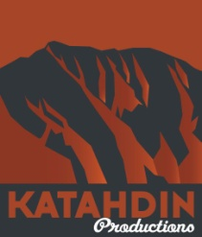Katahdin Productions Press Release

**JOAN ALLEN JOINS DOCUMENTARY *"WHO WILL WRITE OUR HISTORY"***

**TUES, FEB 17, 2015 13:25 PST/FOR IMMEDIATE RELEASE**

Note to Editors: Artwork and photographs are available. Contact Roberta Grossman if interested.

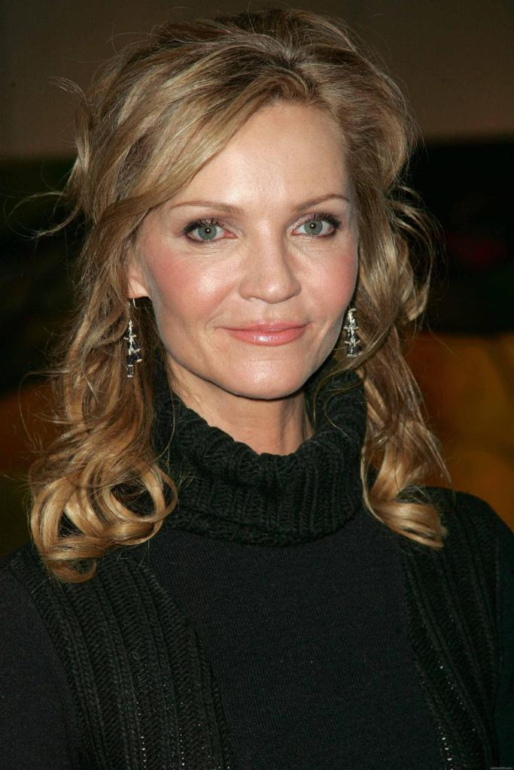

**LOS ANGELES, CALIF., February 17, 2015** – Katahdin Productions announced today that Academy Award-nominated actress Joan Allen (*The Bourne Legacy, The Contender)* has joined Nancy Spielberg and Roberta Grossman's documentary *Who Will Write Our History* as the voice of survivor historian Rachel Auerbach.

As narrated from the memoirs of Rachel Auerbach, *Who Will Write Our History* reveals the gripping story of the secret archives of the Warsaw Ghetto created by historian Emanuel Ringelblum. Ringelblum and more than 60 brave collaborators, including Rachel Auerbach, secretly documented Jewish life in the Ghetto and then buried over 30,000 pages of documents in milk cans and metal boxes on the eve of the Warsaw Ghetto Uprising. As one of only two survivors of the secret archive, Auerbach led rescuers to the buried treasure after the war.

"Rachel was a fighter, fiercely dedicated to preserving the memory of Emanuel Ringelblum and the Ghetto Archive," says Allen. "She was a gifted and prolific writer and yet she has been largely forgotten. I’m gratified to be able to help tell her remarkable story.”

Allen previously collaborated with director Grossman as the voice of Catherine Senesh in the documentary, *Blessed Is the Match: The Life and Death of Hannah Senesh*. Grossman continues her passion for history in *Who Will Write Our History,* saying, "The Ghetto Archives are like the Dead Sea Scrolls coming out of the Ghetto, yet no one knows about them outside of academic circles. This film will change that in the way that only a film can do, by bringing the story to millions of people around the world. I’m excited to tell the story of Emanuel Ringelblum and the Archive from the point of view of the fascinating and brilliant Rachel Auerbach. Joan Allen’s intelligence and warmth will bring Auerbach to life and I’m thrilled to work with her again."

*Who Will Write Our History* is based on the book of the same name by historian Samuel D. Kassow. Production of the documentary begins in Summer 2015.

**Contact: Roberta Grossman**

Katahdin Productions, Los Angeles

323.424.4210 | rgrossman@katahdinproductions.com

www.whowillwriteourhistory.com

(Biographies on following page)

Katahdin Productions Press Release

**"WHO WILL WRITE OUR HISTORY" Biographies**

**About Joan Allen**

­­Tony Award winner and three-time Academy Award nominee **JOAN ALLEN** began her acting career in 1977 with the Steppenwolf Theatre Company. She made her Broadway debut in the 1987 original production of the play *Burn This*, winning the Tony Award for Best Actress in a Play. She also received a Tony Award nomination for her role in the 1988 original production of *The Heidi Chronicles*.

She has received three Academy Award nominations; she was nominated for Best Supporting Actress for *Nixon* (1995) and *The Crucible* (1996), and for Best Actress for *The Contender* (2000). Her other films include *Tucker: The Man and His Dream* (1988), *In Country* (1989), *The Ice Storm* (1997), *Pleasantville* (1998), *The Notebook* (2004), *The Bourne Supremacy* (2004) *The Bourne Ultimatum* (2007) and *The Bourne Legacy* (2012).

**About the Filmmakers**

Director/Producer **ROBERTA GROSSMAN** is an award-winning filmmaker who has written and produced more than forty hours of documentary television. She was the series producer and co-writer of *500 Nations*, the eight-hour CBS mini-series on Native Americans hosted by Kevin Costner. Her 2008 documentary *Blessed Is the Match: The Life and Death of Hannah Senesh* was shortlisted for an Academy Award and nominated for a Primetime Emmy. Grossman most recently produced and directed *Hava Nagila: The Movie* (2013), and directed Nancy Spielberg’s A*bove and Beyond* current in theatrical release. (2014).

Executive Producer **NANCY SPEILBERG** is an accomplished businesswoman, fundraiser and philanthropist. In recent years she has turned her energy and talents to producing documentary films. In 2014 she released *Above and Beyond*, a film about the WWII pilots who volunteered to fly for Israel in the War of Independence. Spielberg served as consultant on the Oscar-winning documentary *Chernobyl Heart*, and is executive producer of *Elusive Justice: The Search for Nazi War Criminals*, which aired nationally on PBS, and the forthcoming documentary *Mimi and Dona*.

Author **SAMUEL D. KASSOW** is the Charles Northam Professor of History at Trinity College. He is author of: *Students, Professors, and the State in Tsarist Russia: 1884-1917*, (University of California Press, 1989); *Between Tsar and People: the Search for a Public Identity in Tsarist Russia*. Edith Clowes, Samuel Kassow, James L. West eds. (Princeton University Press, 1991); *The Distinctive Life of East European Jewry*, (YIVO, New York, 2004); and *Who will Write our History: Emanuel Ringelblum and the Oyneg Shabes Archive*, (Indiana University Press, 2007).

**KATAHDIN PRODUCTIONS** is a nonprofit documentary production company based in Berkeley, California, with production offices in Los Angeles. Founded by Lisa Thomas, cofounder and former CEO of Clif Bar, Inc., Katahdin's mission is to tell compelling stories often ignored by mainstream media—stories that inform, inspire and engage. Katahdin films include: Ab*ove and Beyond (2014)*; *Dorothea Lange: Grab a Hunk of Lightning* (American Masters/PBS 2014); *Hava Nagila: The Movie* (2012); *Blessed is the Match: The Life and Death of Hannah Senesh* (2008); *Homeland: Four Portraits of Native Action* (2005).

**Contact: Roberta Grossman**

Katahdin Productions, Los Angeles

323.424.4210 | rgrossman@katahdinproductions.com

www.whowillwriteourhistory.com